Worksheet 1.2: Circuits
- Work in pairs. One of you choose the two-key safe circuit and one of you choose the automatic shop door circuit.
- Explain how your chosen circuit works to your partner.
- Work together to write down, in the space provided, how each circuit works.
Two-key bank vault circuit
An electronic safe has two switches that are operated by two keys, Key A and Key B. The bank manager keeps one key, and the assistant bank manager keeps the other. Both have to be present to open the safe. The motor (M) unlocks the safe door.

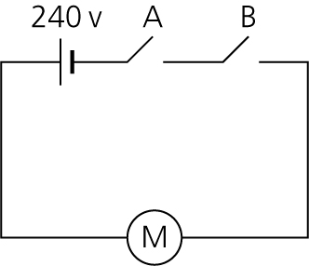

Automatic shop door circuit
An automatic shop door has a sensor switch, A, outside the shop to detect people wanting to come in and another sensor switch, B, inside the shop to detect people wanting to leave. The motor (M) opens the door.

